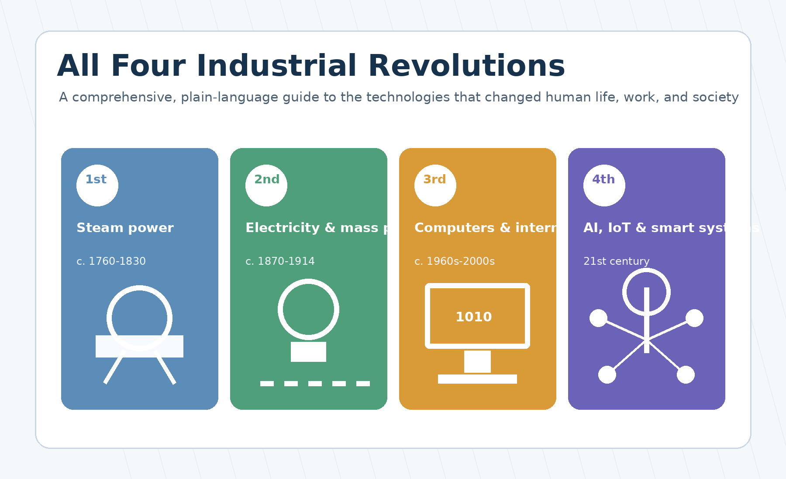
Comprehensive Microsoft Word Report
Simple-language explanations, practical examples, tables, diagrams and references

Contents
- 1. Introduction: What is an Industrial Revolution?
- 2. The First Industrial Revolution
- 3. The Second Industrial Revolution
- 4. The Third Industrial Revolution
- 5. The Fourth Industrial Revolution
- 6. Comparison of the Four Industrial Revolutions
- 7. Real-world effects on daily life and society
- 8. Benefits, risks, challenges and ethical questions
- 9. Lessons for education, policy and future planning
- 10. Conclusion
- References

1. Introduction: What is an Industrial Revolution?
An Industrial Revolution is a period when new technologies change the way people produce goods, organize work, travel, communicate and live. It is not only about machines. It also changes families, cities, education, science, trade, government and even the way people imagine the future.
Before industrialization, most people lived in rural areas and produced many goods by hand. A shirt, a tool or a carriage could take a long time to make because workers used simple tools and human or animal power. During industrial revolutions, machines, new sources of energy and new forms of organization made production faster and cheaper. This created many benefits, but also many social problems that societies had to solve.
Historians often describe four major industrial revolutions. The first was based on steam power and mechanized production. The second was based on electricity, steel, chemicals, oil and mass production. The third was based on electronics, computers, automation and the internet. The fourth is based on intelligent, connected and data-driven systems such as artificial intelligence, the Internet of Things, robotics and biotechnology.
The boundaries between these revolutions are not exact. Changes began earlier in some countries and later in others. Some technologies from an earlier revolution are still used today. However, the four-revolution model is useful because it helps us see how each major wave of technology created a new type of economy and society.
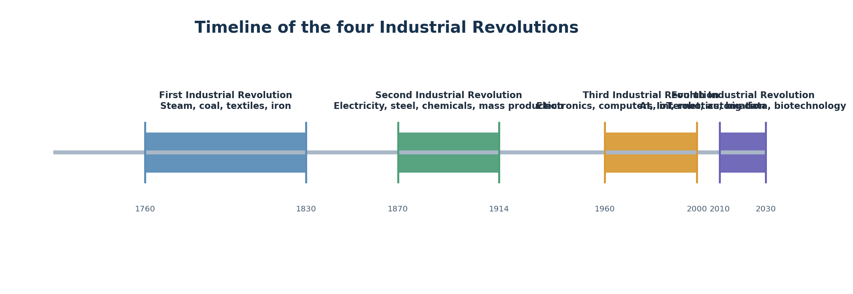
Figure 1. Simplified timeline of the four Industrial Revolutions. Visual created for this report.
Simple definition
An Industrial Revolution is a deep technological and social transformation that changes production, work, transport, communication and everyday life.

2. The First Industrial Revolution

2.1 Historical period and geographical origin
The First Industrial Revolution began in Britain in the second half of the eighteenth century and continued into the early nineteenth century. A common historical period is about 1760 to 1830, although the exact dates vary by source and by country. It later spread to continental Europe, North America and other parts of the world.
Britain became the early center because several conditions came together: access to coal and iron, a growing commercial economy, capital for investment, a strong maritime trade network, technical skills, and a legal environment that protected property and business activity. Agricultural improvements also increased food supply and freed some workers to move to towns and factories.

2.2 Main causes
- Agricultural change: better tools, crop rotation and selective breeding increased food production.
- Population growth: more people created a larger labor force and bigger markets for goods.
- Coal and iron resources: coal provided fuel; iron was essential for machines, rails and tools.
- Capital and trade: merchants and investors could finance factories, canals and machines.
- Scientific and technical culture: inventors and engineers improved machines through experimentation.
- Demand for textiles: cotton cloth became a large market, encouraging mechanized spinning and weaving.

2.3 Key inventions and technologies
Technology | Main use | Why it mattered | Simple explanation
Spinning Jenny | Textiles | Increased thread production | One worker could spin several threads at the same time.
Water frame | Textiles | Used water power for stronger thread | Factories could organize many machines in one place near water.
Power loom | Textiles | Mechanized weaving | Cloth could be woven faster than by hand.
Steam engine | Mining, factories, transport | Provided reliable power | Steam could pump water from mines and drive machines.
Iron improvements | Tools, rails, machines | Made stronger structures possible | Better iron supported factories, bridges and machinery.
Canals and railways | Transport | Moved goods faster and cheaper | Heavy coal and raw materials could travel long distances.

2.4 Steam power
Steam power was one of the central technologies of the First Industrial Revolution. Earlier steam engines were used mainly to pump water from mines. James Watt and other engineers improved steam engines so they became more efficient and could drive factory machinery. This meant factories no longer had to depend only on rivers for power.
Steam also changed transport. Steam locomotives and steamships made travel and trade faster. For producers, this reduced the cost of moving coal, iron, cotton and finished goods. For society, it connected towns and regions more tightly than before.

2.5 Textile production
Textiles were among the first industries to be transformed. Before mechanization, spinning thread and weaving cloth were slow manual tasks. New machines made it possible to produce much more yarn and cloth in less time. This encouraged the growth of factories where machines, workers and power sources were organized together.
The textile industry shows how one innovation creates pressure for another. Faster spinning created more yarn, so weaving had to become faster. Faster weaving created more demand for raw cotton, transport and trade. A single industry therefore changed agriculture, shipping, finance and labor.

2.6 Coal, iron and transport
Coal was the energy base of the first revolution. It heated homes, powered steam engines and supported iron production. Iron was the material base: it was used for machines, bridges, tools, factory structures and later railways.
Transport improved through canals, better roads and railways. Faster transport helped markets grow. A producer could sell goods farther away, and a factory could receive raw materials more reliably. This made regional and national economies more connected.

2.7 Changes in agriculture, society and work
The First Industrial Revolution changed social life deeply. Many people moved from villages to towns to work in factories. Urban populations grew quickly, often faster than housing, sanitation and public health systems. This created crowded living conditions and new social problems.
Factory work was different from farm or craft work. Workers had to follow the rhythm of machines and factory schedules. Work became more specialized, and many tasks were repetitive. At the same time, industrial production created new jobs, new skills and cheaper goods for consumers.
Over time, the problems of industrial society led to reforms: labor laws, public health measures, education reforms, trade unions and new ideas about social responsibility. Industrialization therefore created both material progress and the need for stronger social protections.

3. The Second Industrial Revolution

3.1 Historical period
The Second Industrial Revolution is usually placed from the mid- or late-nineteenth century to the early twentieth century. A common period is about 1870 to 1914. It was more international than the first: Britain, Germany, France, Belgium, the United States and Japan all became major industrial powers.
This revolution is sometimes called the Technological Revolution because it involved many science-based industries: electricity, chemicals, steel, oil, engines, telephones, telegraphs and modern transport systems.

3.2 Electricity
Electricity changed industry and daily life because it was flexible, clean at the point of use and easy to distribute through networks. Electric motors could power individual machines. Electric light extended working hours and improved safety in factories and streets.
Electric power also encouraged new products and services: elevators, streetcars, household appliances, electrical communication and later radio. The electrical grid became one of the most important infrastructures of modern society.

3.3 Steel, chemicals and oil
- Steel: cheaper steel made railways, bridges, ships, machines and skyscrapers possible.
- Chemicals: new chemical industries produced dyes, fertilizers, medicines, explosives and industrial materials.
- Oil: petroleum and internal combustion engines transformed transport through cars, trucks, ships and aircraft.
- Scientific management: factory owners studied work processes to increase speed and consistency.
- Standardization: interchangeable parts and standard sizes made repair and mass production easier.

3.4 Mass production and the assembly line
Mass production means producing large numbers of standardized goods. Instead of one craft worker making a whole product, many workers and machines perform specialized steps. The moving assembly line, famously used in automobile production, made this system much faster.
The benefit was lower cost. Products such as cars, bicycles, sewing machines and household goods became more affordable for many people. The challenge was that work could become monotonous and workers had less control over the pace and content of their tasks.

3.5 Railways, telegraph, telephone and communication
The railway network expanded dramatically during this period. Railways moved people, food, raw materials and finished goods at large scale. They also required accurate timekeeping, standard procedures and complex management systems.
The telegraph and telephone transformed communication. Messages that once took days or weeks could be sent in minutes. This helped businesses coordinate production and trade across long distances. It also changed journalism, diplomacy, finance and family communication.

3.6 Factories, urbanization and global trade
Cities grew as factories expanded. New industrial regions developed around steel, coal, chemicals and transport. Workers needed housing, schools, hospitals, water systems and public transport. This forced governments and municipalities to build modern urban services.
Global trade became larger and more organized. Industrial countries imported raw materials and exported manufactured goods. This connected economies but also created unequal relationships between industrial powers and many colonized or dependent regions.

4. The Third Industrial Revolution

4.1 Historical period and core idea
The Third Industrial Revolution is often called the Digital Revolution. It developed in the second half of the twentieth century and accelerated from the 1960s onward. It was based on electronics, semiconductors, computers, telecommunications, software, automation and the internet.
The main change was that information itself became a central productive resource. In earlier revolutions, machines mainly multiplied physical power. In the digital revolution, computers multiplied the human ability to calculate, store information, communicate and control complex processes.

4.2 Electronics and semiconductors
Electronics made it possible to control machines with circuits instead of only mechanical parts. The transistor and later the integrated circuit allowed computers to become smaller, faster and cheaper. This changed not only offices but also factories, transport, medicine, communication and scientific research.
Semiconductors are the foundation of modern digital life. They are inside computers, mobile phones, cars, medical devices, satellites, industrial machines and home appliances. The ability to put more computing power into smaller devices made digital technology widespread.

4.3 Computers and software
Computers changed how organizations work. Banks, universities, factories, governments and hospitals began to store and process large amounts of information. Software became a new form of infrastructure: invisible but essential for daily operations.
Personal computers brought computing into homes and small businesses. Later, laptops and smartphones made computing mobile. The software industry created new professions such as programmers, systems analysts, database administrators, network engineers and user experience designers.

4.4 Automation
Automation means using machines or software to perform tasks with limited human intervention. In factories, programmable logic controllers, sensors and robots made production more precise and reliable. In offices, software automated accounting, document preparation and data processing.
Automation changed the labor market. Some routine jobs declined, but new technical and service jobs appeared. Workers increasingly needed digital skills, problem-solving ability and the capacity to learn new tools throughout life.

4.5 The internet and digital communication
The internet connected computers across the world. It allowed people to send email, publish websites, search for information, buy goods, watch videos, study online and collaborate across borders. It turned communication into a global, low-cost and almost instant activity.
Digital communication also changed culture and politics. Social media, online journalism and digital platforms made it easier to share ideas but also created new problems such as misinformation, privacy loss, digital addiction and online harassment.
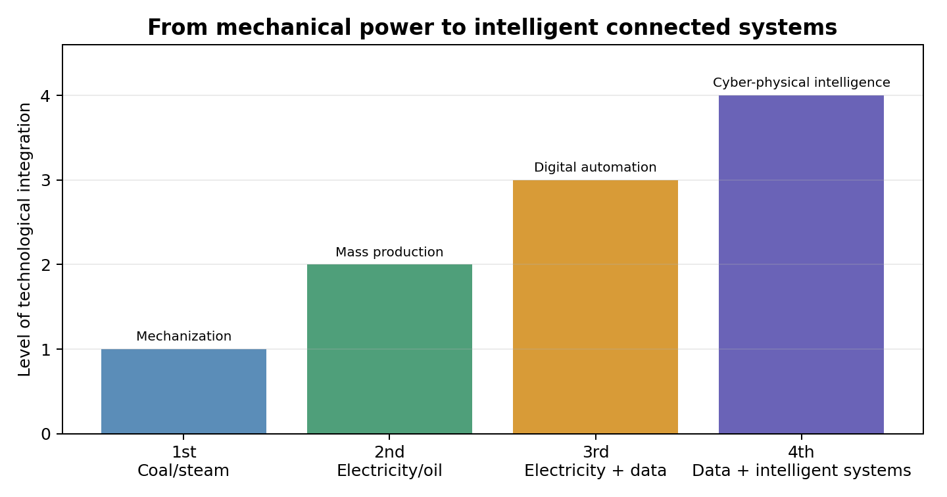
Figure 2. A simplified illustration of increasing technological integration from the first to the fourth revolution.

5. The Fourth Industrial Revolution

5.1 Core idea
The Fourth Industrial Revolution builds on the digital technologies of the third revolution, but it goes further. It connects physical machines, digital software and biological systems. Machines can sense their environment, communicate with each other, learn from data and sometimes make decisions automatically.
A useful simple phrase is: connected intelligence. The fourth revolution is not only about having computers. It is about systems in which devices, data, algorithms, robots and people work together in real time.
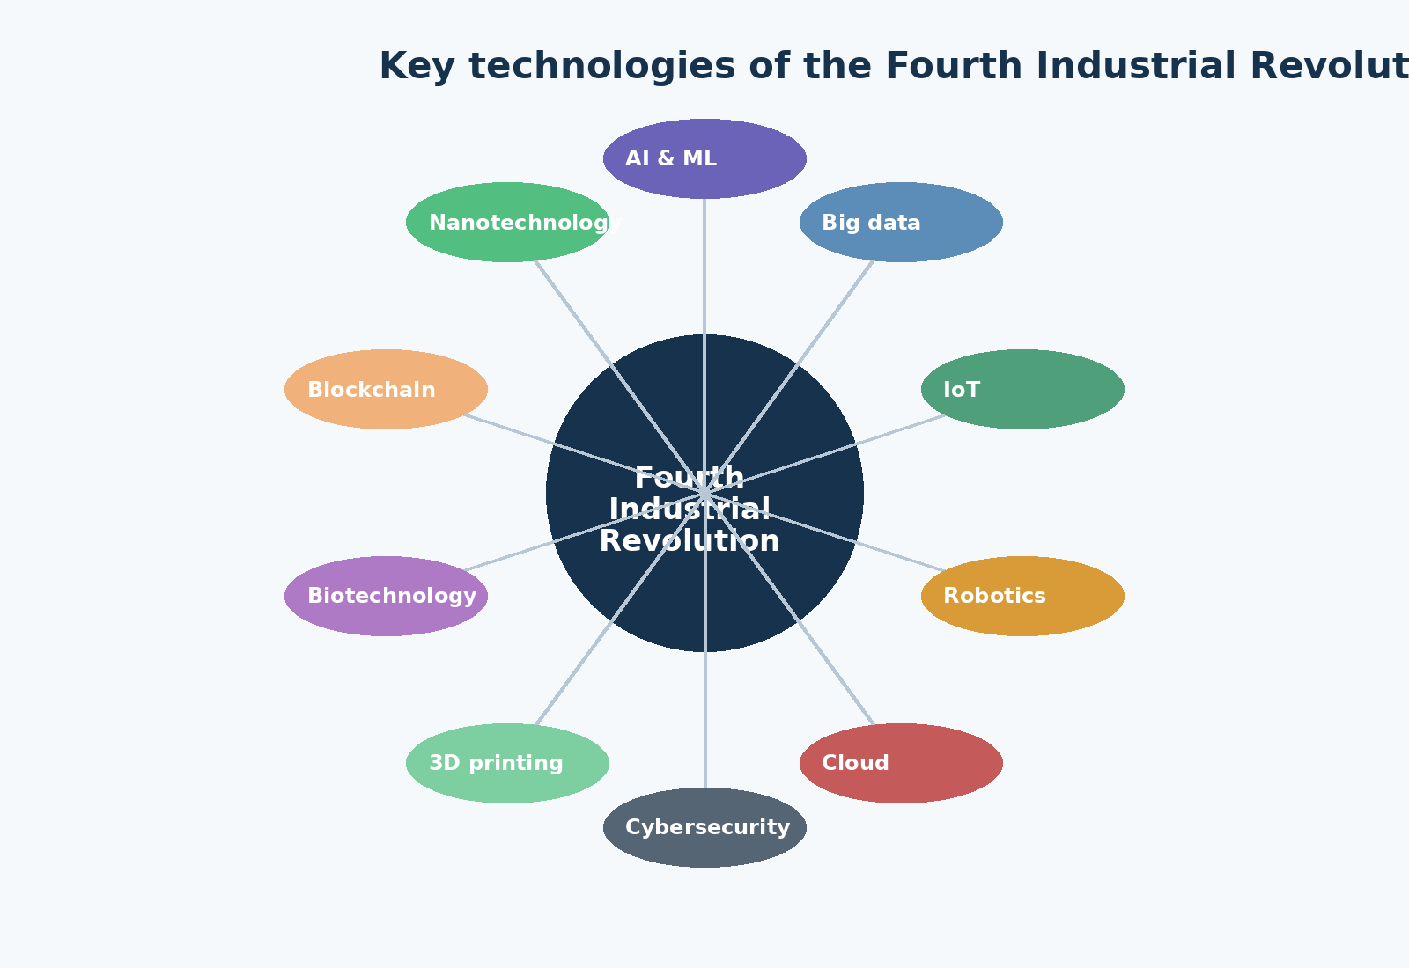
Figure 3. Main technologies commonly associated with the Fourth Industrial Revolution. Visual created for this report.

5.2 Artificial Intelligence and Machine Learning
Artificial Intelligence, or AI, is a group of technologies that allow computers to perform tasks that normally require human intelligence, such as recognizing images, understanding language, finding patterns, making recommendations or planning actions.
Machine Learning is a major part of AI. Instead of programming every rule by hand, engineers train systems using data. For example, a machine-learning system can learn to detect defective products by studying many images of good and defective items.
AI can improve healthcare diagnosis, translate languages, support education, optimize logistics and help researchers analyze huge data sets. However, it also raises questions about bias, transparency, privacy, responsibility and job displacement.

5.3 Big Data
Big data means very large and complex collections of data. The data may come from sensors, mobile phones, websites, medical devices, satellites, industrial machines, financial transactions and public records. The value of big data comes from discovering patterns that would be invisible in small data sets.
In industry, big data can help predict machine failures before they happen. In healthcare, it can help detect disease patterns. In cities, it can support traffic planning. The danger is that data can also be misused, collected without consent or used in ways that reduce privacy.

5.4 Internet of Things
The Internet of Things, or IoT, means connecting physical objects to digital networks. These objects can include factory machines, cars, home appliances, medical devices, power meters, agricultural sensors and city infrastructure.
IoT devices collect data and sometimes act on it. A smart thermostat can adjust heating. A sensor in a factory can report vibration before a machine breaks. A medical wearable can measure heart rhythm. The more objects are connected, the more important cybersecurity becomes.

5.5 Robotics and autonomous systems
Robots are machines that can perform physical tasks. Industrial robots have been used for decades, but modern robots are becoming more flexible because they combine sensors, AI and better control systems. Autonomous systems can make certain decisions without constant human control.
Examples include warehouse robots, surgical robots, drones, autonomous vehicles, agricultural robots and inspection robots for dangerous environments. These systems can improve safety and productivity, but they also require strong rules, testing and accountability.

5.6 Cloud computing and edge computing
Cloud computing means using remote computing resources through the internet. Instead of owning all hardware, organizations can use cloud services for storage, software, data analysis and AI. This makes powerful technology available to smaller organizations.
Edge computing means processing data close to where it is created, for example near a factory machine or inside a vehicle. It is useful when decisions must be made very quickly or when sending all data to the cloud would be too slow or expensive.

5.7 Cybersecurity
Cybersecurity protects digital systems from attack, damage and unauthorized access. In the fourth revolution, cybersecurity is not only an IT issue. It is also a safety issue because digital attacks can affect factories, hospitals, transport systems, power grids and public services.
The more connected a system becomes, the more entry points it may have. Strong cybersecurity requires technical tools, trained people, good procedures, regular updates, backups, risk management and a culture of responsibility.

5.8 Blockchain
Blockchain is a way to record information in a shared digital ledger. The ledger is distributed across many computers, making it difficult to change past records secretly. It is known for cryptocurrencies, but it can also support supply-chain tracking, digital identity and smart contracts.
The usefulness of blockchain depends on the problem. It is not needed for every database. It is most relevant when many parties need a shared record and do not fully trust a single central authority.

5.9 3D printing, biotechnology and nanotechnology
3D printing, also called additive manufacturing, creates objects layer by layer from digital designs. It can make prototypes, customized medical implants, spare parts and complex shapes that are difficult to make with traditional methods.
Biotechnology uses biological systems for useful purposes such as medicine, agriculture, vaccines, diagnostics and environmental solutions. Nanotechnology works at extremely small scales and can create materials with special properties. Together, these fields show how the fourth revolution combines the digital, physical and biological worlds.

5.10 Smart factories and cyber-physical systems
A smart factory uses sensors, connected machines, software, robots and data analytics to monitor and improve production. Machines can report their condition, production lines can adjust automatically, and managers can see real-time information about quality, cost and delivery.
A cyber-physical system connects a physical process with digital monitoring and control. Examples include smart grids, autonomous vehicles, modern aircraft, automated warehouses and advanced manufacturing systems.
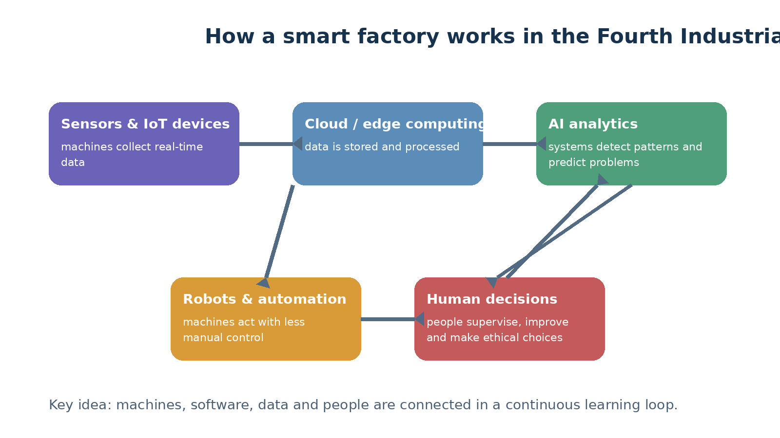
Figure 4. Simplified smart factory loop: sensors collect data, software analyzes it, robots act, and humans supervise decisions.

6. Comparison of the Four Industrial Revolutions
Revolution | Approximate period | Main energy / driver | Core technologies | Economic effect | Social effect
First | c. 1760-1830 | Coal and steam | Steam engines, textile machines, iron, canals, railways | Factory production begins; productivity rises | Urbanization, new working class, labor reforms
Second | c. 1870-1914 | Electricity, oil and steel | Electric motors, steel, chemicals, telegraph, telephone, assembly line | Mass production and global industrial scale | Consumer goods expand; cities and public services grow
Third | c. 1960s-2000s | Electronics and information | Computers, software, semiconductors, automation, internet | Digital services and automated production | New digital jobs; global communication and knowledge access
Fourth | 21st century | Data and intelligent connectivity | AI, IoT, robotics, cloud, big data, biotech, 3D printing | Smart systems, platforms, predictive operations | Personalized services, ethical risks, demand for lifelong learning
Table 1. Comparison of the four Industrial Revolutions.

6.1 What stayed the same?
- Each revolution increased productivity by combining technology, energy, organization and skills.
- Each revolution created new winners and losers, so society had to adapt through education, policy and institutions.
- Each revolution changed transport and communication, making economies more connected.
- Each revolution raised questions about working conditions, inequality and human wellbeing.

6.2 What is different about the Fourth Industrial Revolution?
The fourth revolution is different because it works through data, algorithms and networks. It changes not only physical production but also decision-making. It affects factories, schools, hospitals, banks, governments, art, science and private life.
It is also faster and more global. A digital tool can spread across many countries in a short time. This creates opportunities for rapid progress but also makes risks spread quickly, such as cyberattacks, misinformation or biased automated decisions.

7. Real-world effects on daily life and society
Area | First Revolution | Second Revolution | Third Revolution | Fourth Revolution
Daily life | Cheaper cloth, urban living, factory time | Electric light, household products, cars | Personal computers, mobile phones, online services | Smart homes, AI assistants, personalized services
Work | Factory labor and machine operators | Assembly-line jobs, clerical offices | IT jobs, automation, service economy | Human-machine collaboration, reskilling, platform work
Education | Need for basic literacy and technical skills | Public schooling expands | Digital learning tools and online resources | Personalized learning, AI tutors, lifelong learning
Healthcare | Better transport of supplies, early public health reforms | Modern hospitals, chemistry-based medicines | Medical imaging, digital records, telemedicine | AI diagnosis, genomics, wearable monitoring
Transport | Railways and steamships | Cars, electric trams, airplanes begin | Computerized logistics and navigation | Autonomous vehicles, smart traffic, drones
Communication | Faster printed materials and rail mail | Telegraph, telephone, radio begins | Internet, email, mobile communication | AI translation, immersive communication, connected devices
Table 2. Examples of how the four Industrial Revolutions changed daily life.
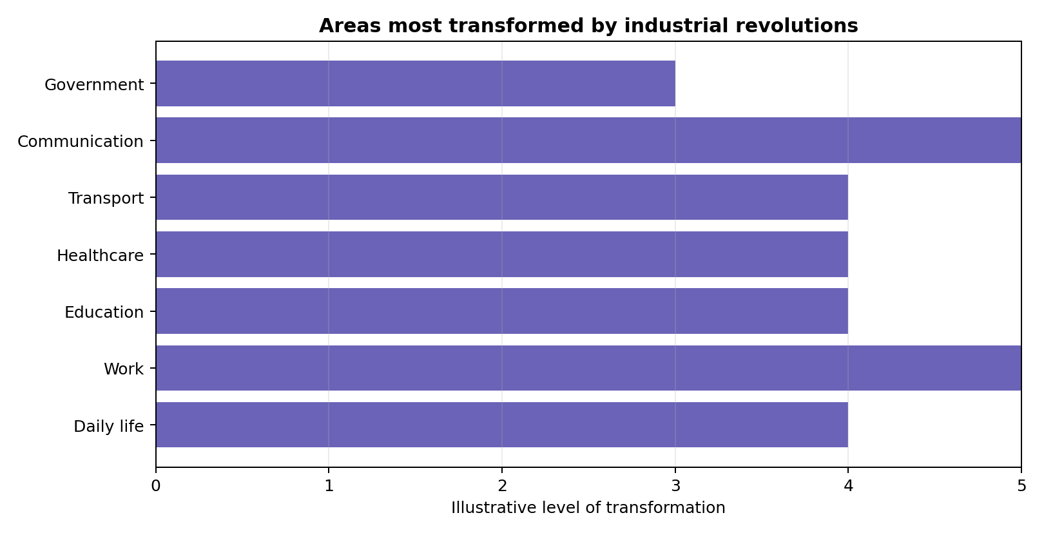
Figure 5. Illustrative view of areas strongly transformed by industrial revolutions.

7.1 Work and the labor market
Industrial revolutions often reduce demand for some old tasks while creating demand for new tasks. The main challenge is the transition. People need time, education and support to move from declining jobs to growing ones. In the fourth revolution, digital and human skills are both important: data literacy, critical thinking, creativity, communication, ethics and technical competence.

7.2 Education
Education becomes more important in every industrial revolution. In the first and second revolutions, workers needed basic literacy, numeracy and mechanical skills. In the third, computer literacy became essential. In the fourth, people need lifelong learning because technologies change quickly. Schools should teach not only facts but also problem-solving, teamwork, digital citizenship and responsible use of AI.

7.3 Healthcare
Healthcare has been transformed by industrial revolutions through better transport, cleaner cities, chemical medicines, electricity, medical devices, computers and now AI and genomics. The future of healthcare may be more preventive and personalized, but it must protect privacy and avoid unequal access.

7.4 Government and public services
Governments are affected because they must regulate new industries, protect citizens, invest in infrastructure and provide education. In the fourth revolution, public services can use data and digital platforms, but they must be transparent, secure and inclusive so that people without advanced digital skills are not excluded.

8. Benefits, risks, challenges and ethical questions

8.1 Benefits
- Higher productivity: more goods and services can be produced with fewer resources.
- Lower prices: mass production and digital services can make products more affordable.
- Better health and safety: machines can perform dangerous tasks and medical technologies can improve diagnosis and treatment.
- New knowledge: scientific instruments, computers and AI can help researchers solve complex problems.
- Greater connectivity: people can communicate, learn and trade across borders.
- Environmental opportunities: smart systems can reduce waste, optimize energy use and support renewable energy networks.

8.2 Risks and challenges
- Job displacement: some tasks and occupations may decline faster than workers can retrain.
- Inequality: people, companies and countries with better access to technology may benefit more.
- Privacy loss: connected devices and digital platforms can collect sensitive data.
- Cybersecurity threats: attacks can disrupt factories, hospitals, transport and public services.
- Bias and unfairness: AI systems can repeat or amplify unfair patterns in data.
- Environmental costs: industrialization can increase pollution, resource use and electronic waste if not managed responsibly.
- Dependence on complex systems: when society relies heavily on digital networks, failures can have wide effects.

8.3 Ethical questions
Question | Why it matters
Who is responsible when an autonomous system causes harm? | Clear responsibility is needed for safety, justice and trust.
How should personal data be collected and used? | People need privacy, consent and protection from misuse.
How can societies share the benefits of technology fairly? | Without policy, innovation can increase inequality.
Should AI systems explain their decisions? | People affected by decisions need transparency and the right to challenge errors.
How can workers be protected during technological transition? | Education, social protection and fair labor standards reduce harm.
How can innovation support environmental sustainability? | Technology should reduce pollution and resource waste, not only increase production.
Table 3. Ethical questions connected with the Fourth Industrial Revolution.

9. Lessons for education, policy and future planning

9.1 Lessons for education systems
- Teach strong foundations: reading, writing, mathematics, science and history remain essential.
- Add digital literacy: students should understand data, algorithms, cybersecurity and online responsibility.
- Teach human skills: communication, teamwork, creativity, empathy and ethical reasoning are difficult to automate.
- Support lifelong learning: adults need flexible opportunities to update skills throughout their careers.
- Connect education with real projects: students learn better when they solve practical problems.

9.2 Lessons for governments
- Invest in infrastructure such as electricity, broadband, cloud services, research facilities and transport.
- Support fair access so that rural areas, poorer communities and small businesses are not left behind.
- Modernize regulation to protect safety, privacy and competition without stopping useful innovation.
- Create strong cybersecurity capacity for public services and critical infrastructure.
- Use public procurement and research funding to encourage responsible innovation.

9.3 Lessons for organizations
- Start with real problems, not technology fashion. Technology should solve clear human or business needs.
- Train employees and involve them in change. People resist technology less when they understand it and help shape it.
- Protect data and systems from the beginning. Security should not be added at the end.
- Measure social and environmental impact, not only profit and speed.
- Keep humans responsible for important decisions, especially decisions that affect rights, safety or dignity.

10. Conclusion
The four Industrial Revolutions show how technology can transform the world. The first revolution mechanized production with steam power. The second created mass production through electricity, steel, chemicals and oil. The third made information digital through electronics, computers and the internet. The fourth is creating intelligent, connected systems that combine the physical, digital and biological worlds.
These revolutions brought enormous benefits: more production, better transport, faster communication, new medicines, new knowledge and new opportunities. They also created serious problems: difficult working conditions, pollution, inequality, privacy risks, cybersecurity threats and ethical questions.
The most important lesson is that technology alone does not guarantee human progress. Progress depends on how societies guide technology through education, ethical rules, responsible business, public policy and international cooperation. The goal should not be simply to make machines more powerful. The goal should be to improve human wellbeing, protect dignity and create a fairer, safer and more sustainable future.

References
- Encyclopaedia Britannica. “Industrial Revolution: Definition, History, Dates, Summary.” Updated 2026. https://www.britannica.com/event/Industrial-Revolution
- Encyclopaedia Britannica. “The Fourth Industrial Revolution,” essay by Klaus Schwab. Updated 2026. https://www.britannica.com/event/The-Fourth-Industrial-Revolution-2119734
- World Economic Forum. Klaus Schwab. “The Fourth Industrial Revolution: what it means and how to respond.” 14 January 2016. https://www.weforum.org/stories/2016/01/the-fourth-industrial-revolution-what-it-means-and-how-to-respond/
- World Economic Forum. “The Fourth Industrial Revolution, by Klaus Schwab.” 25 September 2024. https://www.weforum.org/publications/
- National Geographic Education. “Industrial Revolution and Technology.” Updated 15 November 2024. https://education.nationalgeographic.org/resource/industrial-revolution-and-technology/
- HISTORY. “Industrial Revolution: Definition, Inventions & Dates.” Updated 2026. https://www.history.com/articles/industrial-revolution
- HISTORY. “Industrial Revolution: Definition and Inventions.” https://www.history.com/topics/industrial-revolution
- National Institute of Standards and Technology (NIST). “Cybersecurity and Industry 4.0 - What You Need to Know.” 11 May 2022. https://www.nist.gov/blogs/manufacturing-innovation-blog/cybersecurity-and-industry-40-what-you-need-know
- National Institute of Standards and Technology (NIST). “Industry 4.0 and Cybersecurity - How to Protect Your Investment.” 18 June 2024. https://www.nist.gov/blogs/manufacturing-innovation-blog/industry-40-and-cybersecurity-how-protect-your-investment
- OECD. “Future of Work.” Accessed 2026. https://www.oecd.org/en/topics/policy-issues/future-of-work.html
- OECD. “AI and Work.” Accessed 2026. https://www.oecd.org/en/topics/sub-issues/ai-and-work.html
- ENISA. “Industry 4.0 Cybersecurity: Challenges and Recommendations.” 2019. https://www.enisa.europa.eu/publications/industry-4-0-cybersecurity-challenges-and-recommendations
- Radziwill, Nicole M. “Quality 4.0: Let’s Get Digital.” arXiv, 2018. https://arxiv.org/abs/1810.07829
- Gorham, Christopher. “The 4th Industrial Revolution Effect on the Enterprise Cyber Strategy.” arXiv, 2020. https://arxiv.org/abs/2006.07488
- Alsulaimani, Bandar, and Amanul Islam. “Impact of 4IR Technology and Its Impact on the Current Deployment.” arXiv, 2022. https://arxiv.org/abs/2209.01791
- Wikimedia Commons. “File: Maquina vapor Watt ETSIIM.jpg.” Image reference for Watt-type steam engine. https://commons.wikimedia.org/wiki/File:Maquina_vapor_Watt_ETSIIM.jpg
- Wikimedia Commons. “File: Ford assembly line - 1913.jpg.” Image reference for early assembly-line production. https://commons.wikimedia.org/wiki/File:Ford_assembly_line_-_1913.jpg
- Wikimedia Commons. “File: Classic shot of the ENIAC.jpg.” Image reference for early electronic computing. https://commons.wikimedia.org/wiki/File:Classic_shot_of_the_ENIAC.jpg
- Wikimedia Commons. “File: KUKA Industrial Robots IR.jpg.” Image reference for industrial robotics. https://commons.wikimedia.org/wiki/File:KUKA_Industrial_Robots_IR.jpg
- All diagrams, charts and timeline visuals in this document were created specifically for this report.

